USER INTERFACE DESIGN

EXPERIMENT – 8

Topic: Design Storyboards for online-retailing App using Balsamiq

NAME: ABISHAA R ROLL NO: 240701012

AIM:

To create storyboards representing the user flow for an online-retailing application using Balsamiq.

Tool Used

• Balsamiq Wireframes

Procedure
- Open Balsamiq and create a new project
- Identify key screens like Home, Categories, Product List, etc.
- Add wireframe screens using the “+” option
- Design each screen using UI components (buttons, images, text fields)
- Arrange screens in proper order
- Connect screens using arrows to show user flow
- Keep the design simple and clean

User Flow
Home → Categories → Product List → Product Details → Cart → Payment → Order Confirmation

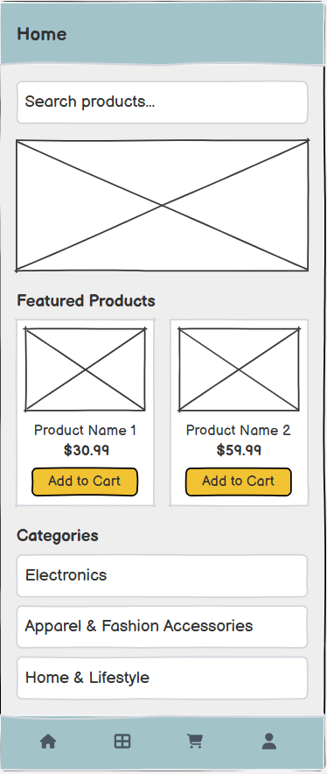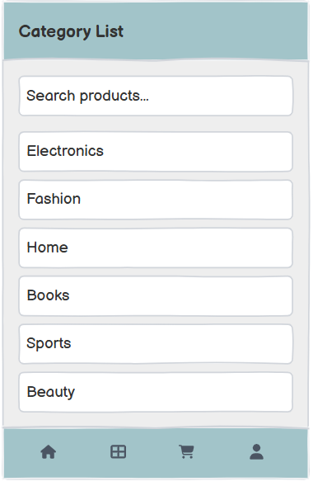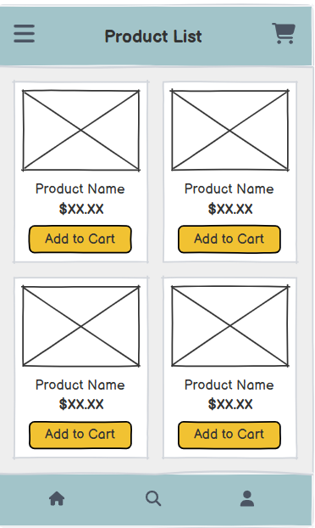
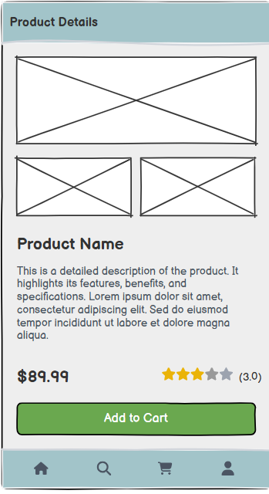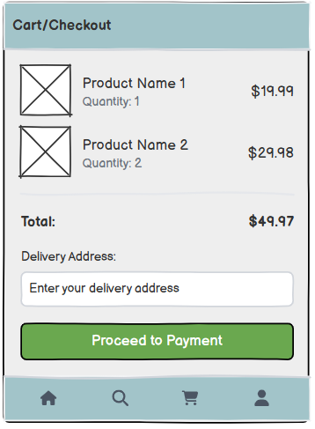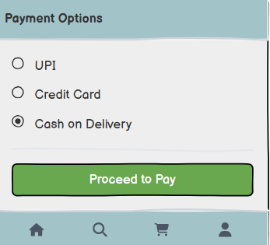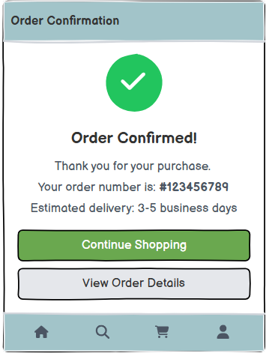

1.Home Screen

- Contains search bar, banner, and featured products
- Helps user start browsing

2.Categories Screen

- Shows categories like Electronics, Fashion
- Helps filter products

3.Product List Screen

- Displays product list with price and Add to Cart button
- Allows users to select items

Product Details Screen

- Shows full product information
- Helps user decide purchase

Cart / Checkout Screen

- Shows selected items and total price
- Allows entering delivery address

Payment Screen

- Displays payment options like UPI, Card, COD
- User completes payment

Order Confirmation Screen

- Shows success message and order details
- Confirms order placement

Result

The storyboard for a online-retailing application was successfully created using Balsamiq, representing the complete user flow from product browsing to order confirmation.

